Epsom & Ewell F.C.
1
v
Raynes Park Vale
Tuesday, 5th August 2014
For our opening home match of the season we welcome our good friends from Raynes Park Vale, along with today's match officials, and of course our own regular faces and interested neutrals.

The break between the seasons gets shorter and shorter, especially in a World Cup year. That hadn’t even finished, yet there we were, playing pre-season friendlies on the same evening. Luckily our opening friendly with Dorking completed in time for me to get home and watch the game of the Century unfold as the Germans left the Brazilian side looking like a team of pub players in their 7-1 Semi-Final defeat. Will we ever see a score like that in a match of such importance again?

I can’t guarantee that we’ll be watching football of that quality today, but over the recent years we have seen some really good stuff under our Manager, Lyndon Buckwell. What he won’t be aware of, is that this Saturday’s fixture at Hartley Wintney will be his 400th in charge; a mark only beaten by two Managers in our history, Pat O’Connell and Adrian Hill. This, added to 100 matches as a player puts him on the big 500, and a presentation will be made before the game to Lyndon to mark this substantial achievement.

There have been a number of changes over the close season, both on and off the pitch. The first item to note is that we have a new Chairman as Pete Beddoe has stepped up to replace Tony Jeffcoate who was in the seat for seven seasons. Steve Dyke has taken on the Vice-Chairman’s role in addition to retaining the position of Treasurer, while Pete remains Secretary.

You will also note a familiar style to the programme. After a season away, many differences have been ironed out and I have returned in the new role of Media Officer. As the season continues it is my intention that you will be kept abreast of substantially more than might previously have been the case in the past. This is YOUR club and we want you all to be as informed and involved as possible while our search for a new ground intensifies. Those who were at the Annual General Meeting will already be aware that things are beginning to happen on that front and it is hoped to have a report from the Holding Company on the progress made before too long.

On the field we have more new faces than has been the case in recent years, along with a sprinkling of old favourites. We kicked off the season at Farnham Town on Saturday, and recorded a solid 2-0 win there. Today we take on another side that recorded a good victory, as Vale defeated the returning Chertsey Town 2-1. We all know this will be a tough match, but we are capable.

We have a lot of journeys coming up shortly. Following the trip to Hartley Wintney, our next match is the big F.A. Cup tie at Hassocks on Saturday 16th August. The Saturday after that we visit Colliers Wood United before returning here on Bank Holiday Monday for a match with Horley Town. In the event we drew with Hassocks, a replay here would be on Wednesday 20th August.

Enjoy the game!

Rich (Richard.c.lambert@virgin.net) on Twitter @EEFCOfficial

Cover photo this week by Gemma Jarman

Sam Currie receives the Dave Wilson Trophy for 2014
from our new Chairman, Pete Beddoe

Cherry Red Records
Combined Counties League
Premier Division Final Table 2013/14
 | P | W | D | L | F | A | Pts | GD | H | A
South Park | 42 | 34 | 2 | 6 | 121 | 41 | 104 | +80 | 0-2 | 2-0
Camberley Town | 42 | 27 | 9 | 6 | 88 | 42 | 90 | +46 | 0-2 | 2-0
Epsom & Ewell | 42 | 24 | 6 | 12 | 87 | 61 | 78 | +26 | x | x
Westfield | 42 | 24 | 5 | 13 | 72 | 51 | 77 | +21 | 2-1 | 0-3
Cove | 42 | 24 | 4 | 14 | 95 | 67 | 76 | +28 | 0-1 | 3-0
Windsor | 42 | 20 | 7 | 14 | 96 | 68 | 67 | +28 | 2-1 | 3-1
Hartley Wintney | 42 | 20 | 5 | 17 | 94 | 77 | 65 | +17 | 4-2 | 4-4
Hanworth Villa | 42 | 18 | 10 | 14 | 82 | 64 | 64 | +18 | 1-4 | 3-3
Wembley | 42 | 18 | 9 | 15 | 64 | 60 | 63 | +4 | 0-2 | 3-1
Raynes Park Vale | 42 | 18 | 8 | 16 | 79 | 81 | 62 | -2 | 2-2 | 3-1
Molesey | 42 | 15 | 12 | 15 | 70 | 53 | 57 | +17 | 2-2 | 2-1
Frimley Green | 42 | 17 | 6 | 19 | 63 | 82 | 57 | -19 | 3-0 | 5-1
Croydon | 42 | 16 | 5 | 20 | 58 | 81 | 53 | -23 | 2-0 | 0-3
Badshot Lea | 42 | 14 | 10 | 18 | 58 | 84 | 52 | -26 | 3-4 | 0-1
Farnham Town | 42 | 14 | 9 | 17 | 60 | 68 | 51 | -8 | 3-2 | 0-3
Colliers Wood Utd | 42 | 14 | 7 | 21 | 69 | 80 | 49 | -11 | 4-0 | 2-0
Bedfont Sports | 42 | 11 | 12 | 19 | 52 | 79 | 45 | -27 | 1-0 | 2-2
Mole Valley SCR | 42 | 11 | 9 | 22 | 69 | 101 | 42 | -32 | 4-0 | 3-0
Horley Town | 42 | 12 | 6 | 24 | 60 | 93 | 42 | -33 | 5-3 | 3-1
Ash United | 42 | 12 | 5 | 25 | 62 | 78 | 41 | -16 | 3-0 | 3-2
Alton Town | 42 | 9 | 7 | 26 | 57 | 93 | 34 | -36 | 0-3 | 1-0
Chessington & Hook | 42 | 9 | 5 | 28 | 58 | 110 | 32 | -52 | 0-1 | 2-2

Champions South Park earned promotion into the Ryman League Southern Division, while Ash United, Alton Town and Chessington & Hook United were relegated.

We have also lost Wembley who were transferred by the F.A. to the Spartan South Midlands League and Croydon who have been moved into the Southern Counties East (formerly Kent) League.

From the Southern League we received old friends and rivals in Chertsey Town, Guildford City and Ashford Town (Mx) who were all relegated.

From Division One of our League come two promoted teams; Spelthorne Sports and Knaphill. Eversley & California were due to be promoted but a late issue with their lights meant that they had to remain in the lower Division, although Ash United did not get a reprieve and we will play with twenty-one teams in our League this season.

Lyndon Buckwell - Manager
Good evening and welcome to our first home game of the new season.

We got off to the perfect start on Saturday, beating Farnham Town away 2-0, while at the same time our visitors were beating highly fancied Chertsey Town, and I’m sure they will make it hard for us as well.

We’ve had to make a few changes to the squad this season with quite a few leaving for new challenges. Defender Jamie Hatfield, midfielders Sam Robinson, Nathan Ayling and Alex McGregor as well as forward Mark Jarman and James Cottee have all moved on and I would like to thank them all for their efforts for Epsom and wish them luck with their new clubs.

Some of the players coming in include former Colliers Wood United keeper Michael Eacott and former Chipstead defender Dan Dean, as well as former Whyteleafe striker Taylor Smith, who some of you will remember ran us ragged in the F.A. Cup last season.

With so many new faces around this season, expectations won’t be high but I’m sure once everybody is settled in we should be looking at a top ten finish.

Lyndon

Pete Beddoe - Chairman
Welcome to what should be an exciting new season for Epsom & Ewell F.C.

A new Committee has now been elected at the recent AGM. We, as the custodians of the Club, are there to ensure to the best of our ability that the Club is run in a proper and unified manner, reflecting the views of all our supporters.

Our success on the playing field is paramount and our manager Lyndon Buckwell and his Management team have the full support of the Committee. As important as having a successful season on the pitch is our project to relocate the Club back to Borough of Epsom & Ewell. We are making positive progress and will keep you fully informed of developments.

If anyone has any concerns, please inform any member of the Committee, and we will endeavour to resolve them. Finally, if there is anybody who feels they can help us, especially on match days that would be most appreciated.

Enjoy the new season!

Peter

Results and Fixtures
Combined Counties League – Saturday 2nd August
Ashford Town (Mx) | 1-2 | Cove
Badshot Lea | 1-1 | Bedfont Sports
Farnham Town | 0-2 | Epsom & Ewell
Hanworth Villa | 3-1 | Guildford City
Hartley Wintney | 1-0 | Colliers Wood United
Horley Town | 2-2 | Frimley Green
Knaphill | 0-6 | Camberley Town
Mole Valley SCR | 4-0 | Westfield
Raynes Park Vale | 2-1 | Chertsey Town
Windsor | 0-1 | Spelthorne Sports
Combined Counties League – Tuesday 5th August
Camberley Town | V | Farnham Town
Chertsey Town | V | Molesey
Cove | V | Hartley Wintney
Epsom & Ewell | V | Raynes Park Vale
Frimley Green | V | Knaphill
Horley Town | V | Mole Valley SCR
Spelthorne Sports | V | Bedfont Sports
Westfield | V | Hanworth Villa
Windsor | V | Badshot Lea
Combined Counties League – Wednesday 6th August
Colliers Wood United | V | Ashford Town (Mx)
Combined Counties League – Saturday 9th August
Camberley Town | V | Molesey
Chertsey Town | V | Mole Valley SCR
Colliers Wood United | V | Windsor
Cove | V | Hanworth Villa
Hartley Wintney | V | Epsom & Ewell
Farnham Town | V | Guildford City
Frimley Green | V | Bedfont Sports
Raynes Park Vale | V | Knaphill
Spelthorne Sports | V | Badshot Lea
Westfield | V | Ashford Town (Mx)
Combined Counties League – Tuesday 12th August
Ashford Town (Mx) | V | Camberley Town
Badshot Lea | V | Farnham Town
Bedfont Sports | V | Westfield
Hanworth Villa | V | Mole Valley SCR
Horley Town | V | Chertsey Town
Knaphill | V | Cove
Molesey | V | Colliers Wood United
Windsor | V | Frimley Green
Combined Counties League – Wednesday 13th August
Guildford City | V | Spelthorne Sports

First Eleven Appearances - (max 54)
Name | Debut | 2013/14 |  |  |  | Career Totals
 |  | App | Sub | Total | Goals | App | Sub | Total | Goals
AYLING Nathan | 15/11/2008 | 47 | 3 | 50 | 6 | 119 | 23 | 142 | 13
BURNS Robbie | 14/08/2007 | 7 | 2 | 9 | 1 | 202 | 14 | 216 | 121
CAMPBELL Kieran | 29/09/2012 | 50 | 0 | 50 | 0 | 52 | 0 | 52 | 0
COTTEE James | 26/11/2011 | 23 | 4 | 27 | 11 | 44 | 9 | 53 | 24
CURRIE Sam | 04/08/2012 | 45 | 3 | 48 | 1 | 94 | 5 | 99 | 2
DEWAR Ali | 29/10/2011 | 18 | 10 | 28 | 3 | 50 | 29 | 79 | 7
DOUGLIN Karl | 03/08/2013 | 40 | 3 | 43 | 13 | 40 | 3 | 43 | 13
DOWNS Carl | 17/09/2011 | 32 | 6 | 38 | 0 | 90 | 12 | 102 | 2
DOWNS Jake | 29/10/2013 | 4 | 1 | 5 | 0 | 4 | 1 | 5 | 0
HARPER Tommy | 15/04/2014 | 1 | 1 | 2 | 0 | 1 | 1 | 2 | 0
HARTT Russell | 10/08/2013 | 1 | 1 | 2 | 0 | 1 | 1 | 2 | 0
HATFIELD Jamie | 11/11/2006 | 42 | 2 | 44 | 0 | 248 | 13 | 261 | 6
HAYWARD Ben | 07/03/2007 | 30 | 4 | 34 | 2 | 236 | 28 | 264 | 18
HENRY Jordayne | 10/08/2013 | 2 | 1 | 3 | 0 | 2 | 1 | 3 | 0
HOUGH Kyle | 14/08/2007 | 29 | 1 | 30 | 21 | 254 | 12 | 266 | 137
JACKSON Reece | 03/08/2013 | 4 | 2 | 6 | 2 | 4 | 2 | 6 | 2
JARMAN Mark | 08/08/2009 | 34 | 7 | 41 | 24 | 131 | 46 | 177 | 76
LEDIJU Richard | 13/08/2013 | 0 | 9 | 9 | 0 | 0 | 9 | 9 | 0
MARVELL Dale | 15/01/2000 | 0 | 1 | 1 | 0 | 250 | 40 | 290 | 80
McGREGOR Alex | 08/08/2009 | 39 | 9 | 48 | 10 | 157 | 54 | 211 | 26
McKAY Alex | 20/12/2008 | 24 | 7 | 31 | 5 | 65 | 22 | 87 | 7
MURPHY George | 28/03/2013 | 32 | 3 | 35 | 2 | 41 | 4 | 45 | 2
MURRAY-PRICE Carlton | 08/03/2014 | 7 | 1 | 8 | 4 | 7 | 1 | 8 | 4
MYERS Antony | 23/12/2006 | 17 | 10 | 27 | 3 | 75 | 33 | 108 | 9
PANAYI Anthony | 14/11/2010 | 30 | 5 | 35 | 2 | 127 | 14 | 141 | 4
PIERSON Matte | 09/10/2013 | 4 | 0 | 4 | 0 | 4 | 0 | 4 | 0
ROBINSON Sam | 22/10/2011 | 10 | 2 | 12 | 2 | 24 | 3 | 27 | 5
SMITH Matt | 08/08/2009 | 5 | 18 | 23 | 0 | 91 | 42 | 133 | 10
TAYLOR James | 26/08/2013 | 17 | 6 | 23 | 1 | 17 | 6 | 23 | 1
TOUGH Ryan | 21/04/2014 | 0 | 1 | 1 | 0 | 0 | 1 | 1 | 0
URBANSKI Marcus | 21/04/2014 | 0 | 1 | 1 | 0 | 0 | 1 | 1 | 0
WHITE Ross | 15/03/2011 | 0 | 2 | 2 | 0 | 14 | 5 | 19 | 4
Own goal |  |  |  |  | 1

From behind the goal
Farnham Town 0-2 Epsom & Ewell – Combined Counties League
Saturday 2nd August 2014

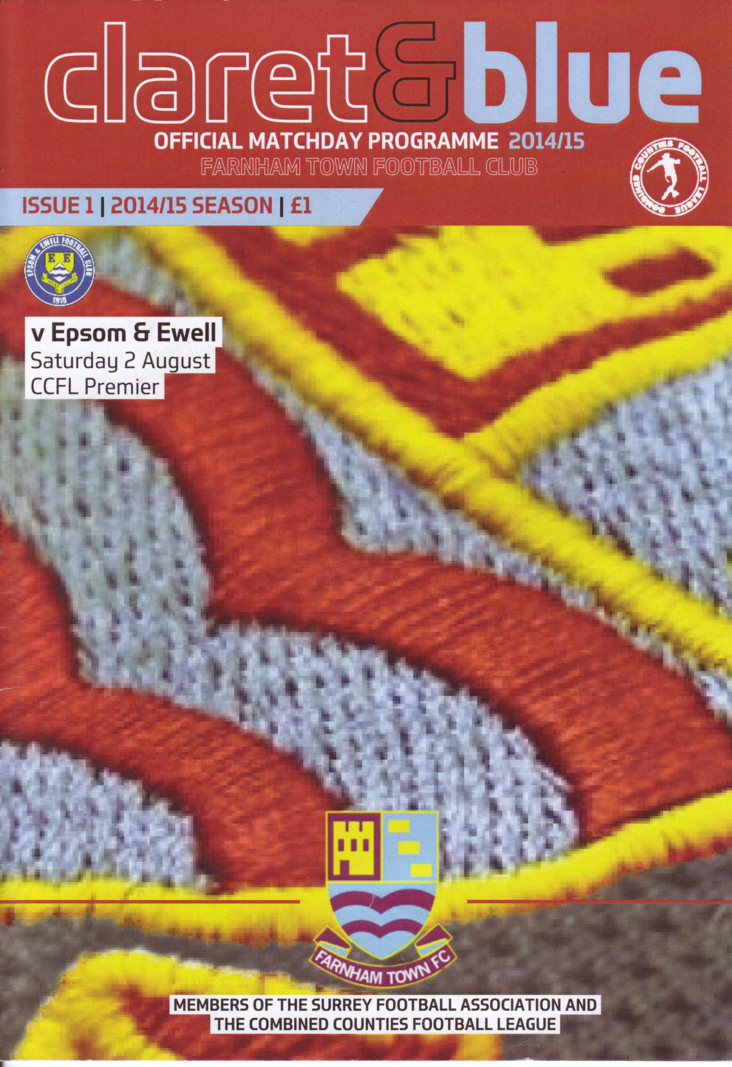The Salts took their pre-season form into the real thing on Saturday and came away with Farnham Town with three points, an achievement they failed to do last season.

Six players made their debut for the club, which equalled the most in any match under Lyndon's tenure (Cove Aug 2011, Colliers Wood Aug 2007) but still eased to victory against their opponents on another hot day.

In truth, the whole occasion seemed affected by the weather as the first half contained periods of possession for both teams, but with no real end result. The hosts lacked a cutting edge of any sort, while for us, Taylor Smith was well marshalled and his service was limited.

Both teams had half chances only. Farnham tried a shot from long distance that was a yard wide of Michael Eacott's right hand post while for us, Kyle Hough couldn't quite get his shot on target after 28 minutes. Ben Hayward nearly scored a brilliant volley after Karl Douglin's corner had been flicked to the far post by a defender, but he was a couple of feet wide of the top corner after 42 minutes. However, there was little else to report on as the teams changed ends at half time.

The hosts had their best chance of the game just after the restart when a right wing cross was headed goalwards, but Eacott was there to make a comfortable save but we responded and Smith made a good run, only to fail with a clever reverse pass attempt to Douglin, and moments later it was Douglin who got through on the right but his shot was blocked out for a corner. From the corner we made the crucial breakthrough. Hough's corner was headed back out to him but he then laid the ball back to Douglin hovering around the edge of the penalty area. His shot was true and into the far corner, giving the keeper no chance after 52 minutes.

Matt Farrell was next to feature as he tried a shot from distance that Lunn the home keeper saved at full stretch and we were beginning to exert a bit more pressure. Douglin had a powerful shot blocked, which looked from where I was to be headed for just inside the far post, but from the break Farnham had a shot on the edge of the area that was deflected wide for a corner.

Our defenders didn't have too much to do to this point but we began to sit back a
little at this point, which invited our opponents on. A decent move resulted in a far post header but it was straight into Eacott's arms and moments later their right

winger got the chance to cross but could only find the side netting.

Of course, when you push forward, you leave spaces and we made the game safe after 89 minutes. A ball in to Smith was held up well, and he then rolled the ball behind him and into the path of Farrell who had time to measure a shot just inside the far post for a goal on his debut.

In summary, I thought we didn't quite hit the heights of our recent friendly performances, but it must be remembered that both us and South Park lost here last year and we went home with a clean sheet, no bookings and of course, three points. You can't argue with that!

Line Up: Michael Eacott, Sam Currie (capt), Matt Tanton, Anthony Panayi, Dan Dean, Carl Downs, Ben Hayward, Karl Douglin, Taylor Smith, Kyle Hough, Matt Farrell
Subs: Sean White for Downs (84), George Murphy for Douglin (90)

Sam Currie – 100 Appearances
On Saturday at Farnham Town our new Captain, Sam Currie became the 114th player in Club History to reach the 100 game mark for the Salts.

He made his debut for us a bit later than originally planned as Lyndon wanted him to join us a year or two before he actually did. In fact, Sam played for us in the Dave Wilson Trophy against Molesey back in August 2010 but he remained with Bookham, finally joining is in August 2012.

Sam made his competitive debut for us in the opening game of the season, a goalless draw at Windsor on 4the August 2012. He made 51 appearances in that first season for us, scoring his first goal for the Salts on that memorable night at Cherrywood Road when we won the League Cup in May 2013.

He scored another acrobatic header in the defeat against Badshot Lea last October but is taking a few free kicks at present, and has scored in our friendly against Walton Casuals so we may see a third goal soon.

Not that the goal scoring part really matters, as Sam is there mainly to defend and he does a very good job of it.

Long may it continue. Congratulations Sam!

Cup Draws for 2014/15
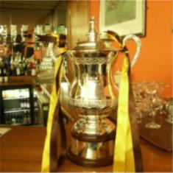

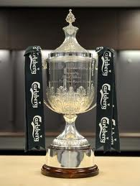After a successful 2012/13 season in cups, 2013/14 was not so good and we found our path blocked by Whyteleafe, Wembley, Chipstead and Spelthorne Sports. We are not entering the Southern Combination Cup this season, so it’s back to just the main four competitions.

The first thing to advise is that our third place finish last season earned us an exemption in the F.A. Vase to the First Round, so there is no draw available until October. This avoids the need for two qualifying rounds, and whilst people might say that we miss out on the opportunity for prize money in those rounds, the figures in the Vase are not that lucrative, and it should also be remembered that the last time we actually played our way through the qualifiers was back in 2008/09, so I think the exemption is very beneficial and a welcome reward for the work put in last season.

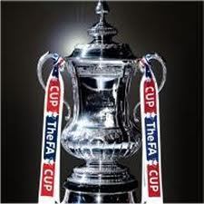In the F.A. Cup we return to Sussex this year for our first ever meeting with Hassocks. They are a decent Sussex League side who finished sixth last season so will be no pushovers. If we were to get past them we would earn a home tie with either Arundel or Croydon, both of whom we know a bit better! In F.A. Cup terms we have defeated Arundel on all three times we have met in this competition (1979/80 replay, 1987/88, 2012/13) while we have made our way past Croydon on both occasions that we have been paired together (1981/82 replay, 2011/12).

In the event that we could win both ties, which would earn us £3,425 in the process, we would have another home tie against one of Burgess Hill Town, Beckenham Town or Eastbourne Town. This would be tougher, and the likely opponents on paper, Burgess Hill are a Step Four team who have knocked us out twice before in the recent past, in 1996 and in 2008 but having home advantage may help us, you never know. We have never met Beckenham in this competition, but have defeated Eastbourne Town on the two occasions we were paired together, in 1979/80 and 1984/85. A win in that round would provide an extra £3,000 and if we play well, all three ties are winnable.

In the League Cup, we have received our first BYE since 2006/07! We have a home tie against newly promoted Knaphill on Tuesday 14th October. We have met once before in this competition, our only meeting so far in fact, and won 3-2 at Redding Way in a First Round tie where we should have won by about eight! However, they are now a Premier Division side so we will have to be careful if we want to match our recent 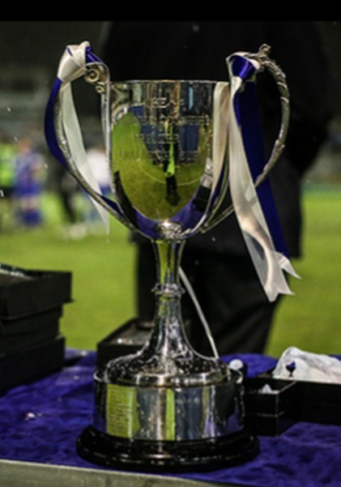successes in the competition.

Finally, we come to the Surrey Senior Cup. This once proud competition has been devalued over the years from a time when the big names in the competition, even us, used to slug out Semi-Finals and Finals on neutral venues in front of many thousands. The move to an open draw was originally thought to give the smaller clubs a chance of a big attendance, but invariably these teams put out shadow squads and as we found out with home ties against Sutton and Leatherhead recently, their supporters have been reluctant to attend.

Regrettably even the Surrey F.A. doesn’t seem as interested and will not even be making the draw until mid-August. What a pity for a competition with such a great history!

Pre-Season Friendlies
Pre-season has been a very happy experience, in fact, the most successful since 1984/85. However, it only counts for so much, and it should be remembered that in 1984 we had to wait until the 3rd November for our first League win!

There has been a bit of a player turnover during the close season and some established faces have moved on. However, some new and some returning players have given cause for optimism.

Firstly, we have the return of Kyle Hough. He is, of course our record penalty taker, but brings so much more to the team from an attacking perspective and appears to be forging a pairing with new boy Taylor Smith, who some will recall scoring three times against us in fifteen minutes for Whyteleafe during that infamous F.A. Cup replay last season. He is lightning fast and still very young. Another youngster to join us is eighteen year old goalkeeper Michael Eacott from Colliers Wood United. Michael clearly has a great future ahead of him and I’m sure he will do well.

Harry Hoadley has joined us and although he is new, technically, he is a returner, having played once for us on loan back in August 2011 while with Leatherhead. He is industrious and will bolster our midfield, where he will be joined by the dynamo that is Karl Douglin and the presence of Carl Downs. I thought we’d lost him to Youth Football Management, but happily he has changed his mind.

On the debit side, Club Captain Jamie Hatfield and Nathan Ayling have taken a step up to the Ryman League with South Park, while Alex McGregor has moved to Dorking Wanderers and James Cottee has moved to Chertsey Town. Finally, Mark Jarman has chosen to retire from football to pursue a career as a DJ, where I hear he is quite good, and we have also lost Sam Robinson, but I’m not sure where to, right now! We thank them all for their considerable efforts over the last few years.

We were originally due to start our season on Saturday 5th July but Loxwood failed to get a team up! As a result we hastily arranged a friendly with Dorking for Tuesday 8th July and eased to a comfortable 6-2 win at the Wimbledon Common Extensions with goals from Ben Hayward, Taylor Smith, o.g. Harry Hoadley, Tommy Harper and Jakub Kurdziel in that order.

We then entertained Farleigh Rovers at Surbiton Town three days later and were held to a 2-2 draw. The visitors opened up with a long range drive but Anthony Panayi’s header went in off a defender for an equaliser and although we trailed again in the second half, a nice finish from Richard Lediju ensured that honours finished even although both teams missed gilt-edged opportunities to win the game towards the end.

We were at Capel F.C.s ground in Beare Green the following Saturday where we defeated Walton Casuals by two clear goals. This was a very controlled performance with strikes from Kyle Hough just before the break, and from Sam Currie just after it! The visiting keeper had a great game and saved many of our attempts, while for us, midfielder Matt Farrell stepped between the posts for the final few minutes, following an injury to Michael Eacott and produced a superb save low to his right to tip the ball onto the post and preserve our clean sheet.

We followed this up three days later with a hard fought 3-2 win at St Francis Rangers’ Colwell Ground, despite trailing early in each half, before levelling up twice through Taylor Smith. Karl Douglin then scored a late winner with all three assists from Kyle Hough.

Things got better still with a thumping 5-2 win at Horsham YMCA on Saturday 26th July, which brought the added bonus of securing the Dave Wilson Trophy for only the second time. Taylor Smith scored another two, with Karl Douglin, Matt Farrell and Alex Tilly on the score sheet.

Our final friendly was at the Arena against our old friends from Croydon last Wednesday. We will not be meeting them in the League following their transfer to the Southern Counties East League, but might see them in the F.A. Cup if results go that way, and we defeated them 2-1 with two strikes from Ali Dewar, after we had trailed at half time. All in all, it is a very promising start!

Centre page for results

Centre page for results

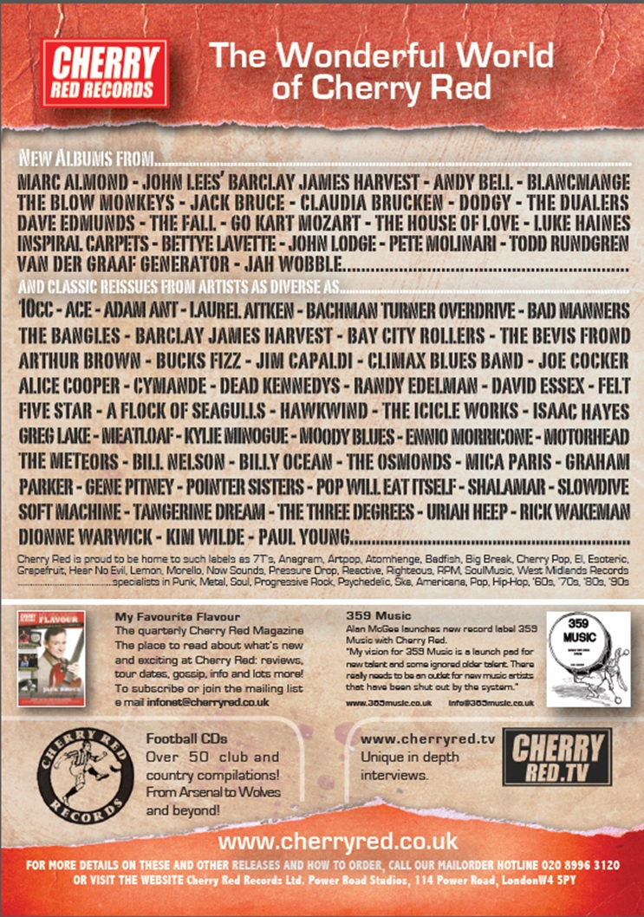

Lyndon Buckwell – 500 not out!
Our Manager Lyndon Buckwell celebrates his 400th match in charge this coming Saturday against Hartley Wintney, which, when added to his 100 appearances as a player, brings him to a very large milestone for the club. By way of a thank you, here is a review of his time with us.

Lyndon Roy Buckwell was born on 9th January 1969 and first played for Epsom & Ewell on Tuesday 4th October 1988 at West Street in a 3-0 home win over Horsham. Lyndon was mostly a full back in his time with us and our Manager at the time was Ricky Kidd.

Ricky was quite keen on putting some of our better players on contract, and on 7th February 1989 Lyndon signed one with the club, paying the princely sum of £8 per week with a financial bonus of £3 for every appearance for the First Eleven! Other players who signed contracts with us that week were winger David Fry and goalkeeper Jason Hopper and we played in the Isthmian League Second Division South.

Lyndon made twenty appearances that season and was more involved the following term when he made forty appearances which, along with Neil Robson, was the most by any player that season. Kidd departed in March 1990 and while many players left at that time, Lyndon remained under the returning Manager Adrian Hill, playing the final nine games of the season.

In 1990/91, he was joined at the club by his younger brother Scott and on 29th September 1990 at Eastbourne, both brothers took the field for the First Eleven at the same time, a feat that doesn’t happen very often. Incredibly, on 20th October 1990, we then had two pairs of brothers on the field, as the Buckwells were joined by the Boxall brothers Andy and Jeremy and all four played in the next six matches as well!

Unfortunately on 13th April 1991, Lyndon tore ligaments in the first half of the match against Leatherhead and we just missed out on a top half finish, which due to League reorganisation meant an effective relegation to the Isthmian League Division Three.

However, Lyndon was destined to play at a higher level than that and left the club for Kingstonian the following season with his tally of appearances at 98. He also went on to play for Molesey and Corinthian Casuals with much success before stepping into Management at Casuals with the Reserve Team alongside another former player and Legend Tony Coombe who has remained by his side ever since.

Upon the dismissal of Paul Pritchard in the early part of 2006/07 Lyndon became just our eighth different Manager in forty years. Under his tenure, things have improved greatly with four top five finishes in the League and of course, a League Cup win in May 2013; our first trophy since 1981.

Despite advancing years in playing terms, Lyndon also found himself called into action on two occasions as a player, enabling him to reach the 100 appearance mark. Unfortunately his final outing at Farnborough’s Cherrywood Road against Badshot Lea resulted in a harsh sending off by an inexperienced referee, giving him the unfortunate record of being the oldest player ever sent off for us at the age of 41 years and 112 days. Seeing as the average age of our squad is now around 24 it seems unlikely that anyone will be taking that record away, unless Coombsey gets a run out, of course.

So today we present Lyndon with a framed memento of his time at the club; an original match programme from his first game in charge, a 3-0 win at Meadowbank against Bookham on 4th November 2006. Thanks for the memories Lyndon!

Club Directory
ASHFORD TOWN (Mx) Telephone: 01784-245908 - Ground: The Robert Parker Stadium, Short Lane, Stanwell. TW19 7BH - Colours: Tangerine & White Stripes/Black/Tangerine

BADSHOT LEA Telephone: 01252-320385 - Ground: Ash United FC, Shawfield Stadium, Youngs Drive, Shawfields Road, Ash, Hampshire. GU12 6RE - Colours: Claret/White/Claret

BEDFONT SPORTS Telephone: 0208-831-9067 - Ground: Bedfont Sports Club, Hatton Road, Bedfont, Middx TW14 8JA - Colours: Red & Black Hoops/Black/Red & Black Hoops

CAMBERLEY TOWN Telephone: 01276-65392 - Ground: Krooner Park, Wilton Road, Camberley, Surrey. GU15 2QW - Colours: Red & White Stripes/Blue/Red

CHERTSEY TOWN Telephone: 01932-561774 - Ground: Alwyns Lane, Chertsey, Surrey. KT16 9DW - Colours: Royal Blue & White Stripes/Royal Blue/Royal Blue

COLLIERS WOOD UNITED Telephone: 0208-942 8062 - Ground: Wibbandune Sports Ground, Lincoln Green, Opposite 199-213, Robin Hood Way, Wimbledon. SW20 0AA - Colours: Blue & Black Stripes/Black/Black

COVE Telephone: 01252-543615 - Ground: Oak Farm Fields, 7 Squirrel Lane, Cove, Farnborough, Hampshire. GU14 8PB - Colours: Yellow/Black/Yellow

EPSOM & EWELL Telephone: 01737-553250 - Ground: Chipstead FC, High Road, Chipstead, Surrey. CR5 3SF - Colours: Royal Blue & White Hoops/Royal Blue/Royal Blue & White Hoops

FARNHAM TOWN Telephone: 01252-715305 Ground: Memorial Ground, Babbs Mead, West Street, Farnham, Surrey. GU9 7DY Colours: - Claret & Sky Blue /White/ Claret & Sky Blue

FRIMLEY GREEN Telephone: 01252-835089 - Ground: Frimley Green Recreation Ground, Frimley Green Road, Frimley Green, Camberley, Surrey. GU16 6JY - Colours: Blue & White/Blue/Blue

GUILDFORD CITY Telephone: 01483-443322 - Ground: The Spectrum, Parkway, Guildford, Surrey. GU1 1UP - Colours: Red & White Stripes/Black/Black

HANWORTH VILLA Telephone: 0208-831-9391 - Ground: Rectory Meadows, Park Road, off Hounslow Road, Hanworth, Middlesex. TW13 6PN - Colours: Red & White Stripes/Black/Black

HARTLEY WINTNEY Telephone: 01252-843586 - Ground: Memorial Playing Fields, Green Lane, Hartley Wintney, Hants RG27 8DL - Colours: Orange & Black/ Orange /Orange

HORLEY TOWN Telephone: 01293-822000 - Ground: The New Defence, Anderson Way, Court Lodge Road, Horley, Surrey. RH6 8SP - Colours: Claret & Sky Blue/Claret/Claret

KNAPHILL Telephone: 01483-475150 - Ground: Brookwood Country Park, Redding Way, Lower Guildford Road, Knaphill, Surrey. GU21 2AY - Colours: Red/Black/Red

MOLE VALLEY SCR Telephone: 01932-866386 - Ground: Cobham FC, Leg O’Mutton Field, Anvil Lane, Downside Bridge Road, Cobham, Surrey KT11 1AA - Colours: Yellow/Black/Black

MOLESEY Telephone: 0208-979-4283 - Ground: 412 Walton Road, West Molesey, Surrey KT8 2JG - Colours: White/Black/Black

RAYNES PARK VALE Telephone: 020-8540-8843 - Ground: Prince Georges Playing Field, Grand Drive, Raynes Park, London. SW20 9NB - Colours: Blue/Blue/Red

SPELTHORNE SPORTS Telephone: 01932-961055 - Ground: Spelthorne Sports Club, 296 Staines Road, Ashford Common, Ashford, Middx. TW15 1RY - Colours: Light & Dark Blue/Dark Blue/Light Blue

WESTFIELD Telephone: 01483-771106 - Ground: Woking Park, Kingfield Road, Woking, Surrey. GU22 9BA - Colours: Yellow/Black/Black

WINDSOR Telephone: 01753-860656 - Ground: Stag Meadow, St Leonards Road, Windsor, Berks SL4 3DR - Colours: Red/Red/Red

Raynes Park Vale F.C. – History
Raynes Park Vale FC was founded in 1995 from the merger of two clubs, Raynes Park FC and Malden Vale FC.

Raynes Park FC was founded in 1964, taking over from the Southern Railway Football Section. These details were confirmed by our current President, Robert Hallett Snr. who was instrumental in the formation of the club.

From these humble beginnings, the club ran five senior teams on Saturdays. The 1st & 2nd XI's played out of the Surrey Premier League. The 3rd team played in the Surrey South Eastern Counties League, whilst the 4th & 5th teams played in the Kingston & District. Raynes Park also had an over 35's team who played their matches on Sundays and also ran teams from under 14's to under 18's.

Malden Vale FC was founded in 1967 by the then Chairman Stephen Pearce. They spent their first decade of existence playing in the North Surrey Youth League, the Sunday Sportsman League, South Thameside League & the Surrey Combination League. Malden Vale won a total of 37 honours at junior & intermediate level.

Malden Vale gained senior status in the 1977-78 season and were duly elected to the Surrey Senior League. The following season the league changed its name to the Home Counties League. After one season in the newly named league, Malden Vale applied to join the London Spartan League. They were accepted into the Premier Division. Ten seasons later in the 1988-89 season Malden Vale finished runners-up to BAE Weybridge in the Dan Air League and were promoted to the Diadora League Division 2 South. All of the club's members worked extremely hard to gain C Grade status for entry into the league.

The club survived for 5 seasons in the Diadora Isthmian League. At the end of the successful 1993-94 season, managers Mick Brown & Ged Murphy left the club to join Hendon. Unfortunately many of the players followed them and Malden Vale finished bottom of the table the following season.

On Saturday 18th August 1995, after two years in the planning, the newly formed Raynes Park Vale FC played its first match in the Combined Counties League.

The London Playing Fields Society, the previous owners of the ground were in financial difficulties and in order to preserve their other facilities they sold Prince Georges’ Playing Fields to a consortium associated through Charles Koppel to Wimbledon AFC for their academy. Wimbledon AFC regrettably were relegated and an academy was unnecessary and they were already planning the move to Milton Keynes where they now reside as MK Dons.

We continue as custodians of the club and environs, the pitch having improved significantly over the last two years under the careful stewardship of Micky Cox to whom we offer our grateful thanks. The club continue to look at alternative sites as a possible new home.

First Team Fixtures - 2014/15 (HOME GAMES IN CAPITALS)
02/08/14 | Sat | Farnham Town - W2-0 | CCL | 06/12/14 | Sat | HANWORTH VILLA | CCL
05/08/14 | Tue | RAYNES PARK VALE | CCL | 13/12/14 | Sat | Badshot Lea | CCL
09/08/14 | Sat | Hartley Wintney | CCL | 20/12/14 | Sat | Bedfont Sports | CCL
16/08/14 | Sat | Hassocks | FAC | 27/12/14 | Sat | Raynes Park Vale | CCL
23/08/14 | Sat | Colliers Wood United | CCL | OR |  | 14/02/15 (if p-p) | CCL
25/08/14 | Mon | HORLEY TOWN | CCL | 03/01/15 | Sat | WINDSOR | CCL
30/08/14 | Sat | GUILDFORD CITY | CCL | 10/01/15 | Sat | Ashford Town (Mx) | CCL
OR |  | CROYDON / ARUNDEL | FAC | 17/01/15 | Sat | FARNHAM TOWN | CCL
02/09/14 | Tue | CHERTSEY TOWN | CCL | 24/01/15 | Sat | --SPARE-- | CCL
06/09/14 | Sat | Hanworth Villa | CCL | 31/01/15 | Sat | WESTFIELD | CCL
13/09/14 | Sat | FRIMLEY GREEN | CCL | 07/02/15 | Sat | CAMBERLEY TOWN | CCL
20/09/14 | Sat | Knaphill | CCL | 14/02/15 | Sat | See 27/12/14 above | CCL
23/09/14 | Tue | Westfield | CCL | 21/02/15 | Sat | HARTLEY WINTNEY | CCL
27/09/14 | Sat | Spelthorne Sports | CCL | 28/02/15 | Sat | Molesey | CCL
04/10/14 | Sat | --SPARE-- |  | 07/03/15 | Sat | COVE | CCL
11/10/14 | Sat | BEDFONT SPORTS | CCL | 14/03/15 | Sat | Chertsey Town | CCL
14/10/14 | Tue | KNAPHILL | CCLC | 21/03/15 | Sat | BADSHOT LEA | CCL
18/10/14 | Sat | ASHFORD TOWN (MX) | CCL | 28/03/15 | Sat | --SPARE--
25/10/14 | Sat | Camberley Town | CCL | 04/04/15 | Sat | COLLIERS WOOD UTD | CCL
01/11/14 | Sat | --DRAW AWAITED-- | FAV | 06/04/15 | Mon | Horley Town | CCL
08/11/14 | Sat | --SPARE-- |  | 11/04/15 | Sat | Windsor | CCL
11/11/14 | Tue | SPELTHORNE SPORTS | CCL | 18/04/15 | Sat | KNAPHILL | CCL
15/11/14 | Sat | Cove | CCL | 25/04/15 | Sat | Frimley Green | CCL
18/11/14 | Tue | Mole Valley SCR | CCL | tba |  | unknown | SSC
22/11/14 | Sat | MOLESEY | CCL
29/11/14 | Sat | Guildford City | CCL

Scouting the Opponent - Hassocks
We make a trip into the unknown on Saturday week when travelling to Hassocks for the first ever meeting between the clubs in the big F.A. Cup tie.

There is £1,500 available to the winners, plus the opportunity to boost that figure to nearly £3,500 if we could then defeat Arundel or Croydon at home in the next round, and a home tie available after that, so there is plenty to play for.

We know very little about them currently, although I’m sure we’ll be sending someone to watch them before we play. Their League position of sixth last season is comparable to ours, so it should be a close game if we can keep our form up.
Hassocks’ picturesque Beacon ground.

Sussex County League Final Table 2013/14
 | P | W | D | L | F | A | Pts | GD
East Preston | 38 | 30 | 6 | 2 | 92 | 23 | 96 | 69
East Grinstead Town | 38 | 24 | 7 | 7 | 84 | 39 | 79 | 45
Littlehampton Town | 38 | 24 | 5 | 9 | 85 | 41 | 77 | 44
Horsham YMCA | 38 | 22 | 10 | 6 | 110 | 45 | 76 | 65
Crowborough Athletic | 38 | 21 | 7 | 10 | 69 | 41 | 70 | 28
Hassocks | 38 | 17 | 9 | 12 | 72 | 65 | 60 | 7
Pagham | 38 | 16 | 10 | 12 | 66 | 57 | 58 | 9
Dorking Wanderers | 38 | 16 | 7 | 15 | 68 | 63 | 55 | 5
Ringmer | 38 | 16 | 5 | 17 | 61 | 64 | 53 | −3
St Francis Rangers | 38 | 15 | 6 | 17 | 66 | 68 | 51 | −2
Chichester City | 38 | 14 | 9 | 15 | 53 | 65 | 51 | −12
Arundel | 38 | 15 | 5 | 18 | 58 | 68 | 50 | −10
Newhaven | 38 | 13 | 10 | 15 | 67 | 63 | 49 | 4
Shoreham | 38 | 12 | 8 | 18 | 65 | 82 | 44 | −17
Lingfield | 38 | 12 | 6 | 20 | 70 | 88 | 42 | −18
Hailsham Town | 38 | 13 | 3 | 22 | 63 | 91 | 42 | −28
Selsey | 38 | 12 | 5 | 21 | 45 | 76 | 41 | −31
Lancing (-6 pts) | 38 | 12 | 8 | 18 | 55 | 80 | 38 | −25
Rye United | 38 | 6 | 8 | 24 | 38 | 45 | 26 | −7
Worthing United | 38 | 2 | 2 | 34 | 22 | 145 | 8 | −123

Match and Ball Sponsorships – 2014/15
Opponent | Date | Match Sponsor | Ball Sponsor
Raynes Park Vale | 05/08/14 | Club President - Stella Lamont
Horley Town | 25/08/14
Guildford City | 30/08/14 | Provisional and dependent on Cup progress
Croydon / Arundel (FAC) | 30/08/14 | Provisional and dependent on Cup progress
Chertsey Town | 02/09/14
Frimley Green | 13/09/14 | Provisional and dependent on Cup progress
(F.A. Cup 1q) | 13/09/14 | Provisional and dependent on Cup progress
Mole Valley SCR | 07/10/14
Bedfont Sports | 11/10/14
Knaphill (LC) | 14/10/14
Ashford Town (Mx) | 18/10/14
Spelthorne Sports | 11/11/14
Molesey | 22/11/14 | Provisional and dependent on Vase progress
Hanworth Villa | 06/12/14
Windsor | 03/01/15
Farnham Town | 17/01/15
Westfield | 31/01/15
Camberley Town | 07/02/15
Hartley Wintney | 21/02/15
Cove | 07/03/15
Badshot Lea | 21/03/15
Colliers Wood United | 04/04/15
Knaphill | 18/04/15
For League Matches:

Match sponsorship - £40.00 Match ball sponsorship - £25.00.
Combined Offer of Match and Match Ball sponsorship for £55.00.

For Cup Matches:

Match sponsorship - £50.00 Match ball sponsorship - £30.00.
Combined Offer of Match and Match Ball sponsorship for £65.00.
----------------------------------------------------------------------------------------------------------------
Sponsorship includes

Admission, programmes, advertising (if required) and hospitality.

If you are interested, just speak to a Committee Member, you know where we are!
Alternatively, drop an email to richard.c.lambert@virgin.net

Our New Website
From this week onwards we have a new website. It is at: http://www.eefconline.co.uk/

For those who are unaware, the new website, constructed by Media Officer Richard Lambert, contains everything you could possibly want to know about the club, and an enormous amount you probably weren’t that bothered about!

The previous site will still exist, but will become a photographic archive only, housing the enormous wealth of photographs provided by Gemma Jarman, who I’m pleased to say will be at many of our matches this season. In addition, all older images that were available through the historical site will also be transferred there shortly.

If you are a supporter, please pass the address on to anyone you know that has ever expressed an interest in the club, especially those who don’t visit any more. You never know, some of them might be inspired to come along too, and bring their friends etc.

Combined Counties League – Premier Division
Tuesday, 5th August 2014 - Kick-off 7.45 p.m.
Epsom and Ewell  (Royal Blue & White hoops) | V |  | Raynes Park Vale  (Yellow, Red, Yellow)
 | NUMBERS
Michael Eacott |  |  | Sam Filler
Elliott Nelmes |  |  | Kevin Wheeler
Anthony Panayi |  |  | Kyle Bailey
George Murphy |  |  | Mark Waters
© Sam Currie |  |  | Shane McEntaggart
Harry Hoadley |  |  | John Makin
Matt Farrell |  |  | Brendon Vickery
Karl Douglin |  |  | Marcus Dowdeswell
Taylor Smith |  |  | Anthony Moulds
Kyle Hough |  |  | Marc Skinner
Ali Dewar |  |  | Najeem Youngman
Julian Van Gelder |  |  | Calum Forbes
Matt Tanton |  |  | Jerome Smart
Lionel Mutima |  |  | Peter Hickford
Kieran Campbell |  |  | Paul Roberts
Ben Hayward |  |  | Ardit Shehu
Richard Lediju |  |  | Stuart Watkins
Alex Tilly |  |  | Jono Key
Alex McKay |  |  | Ali Wiltshire
Jakub Kurdziel |  |  | Simon Moore
Carl Downs |  |  | Dave Weatherhead
Sean White |  |  | Connor Turner
James Taylor |  |  | Ato Okai
Dale Marvell
Lyndon Buckwell | MANAGER |  | Gavin Bolger & Terry Tuvey
Glyn Mandeville | ASSISTANT
Tony Coombe | CHIEF SCOUT
Matt Smith | COACH |  | Rob Tuvey
Ken Jones | PHYSIO |  | tbc
REFEREE: Mr H.Gilroy (Chiswick)
ASSISTANTS: Mr M.Stevens (Morden), Mr S.Potter (Sutton)
Today’s Match and Match Ball are sponsored
by our Club President, Stella Lamont

OUR NEXT VISITORS TO HIGH ROAD
Horley Town
Monday 25th August 2014 - Kick-off 11.30 a.m.
Combined Counties League – Premier Division

